Advanced Database Training
2026
Vaishnavi Kamthe

Assignment 6a

Question
Following image shows the Star Schema model. Based on that please do the following,
- Create the tables in mysql database as per the schema
- Add appropriate columns in every table, give primary key, foreign keys whenever applicable
- Insert rows in each table
- Write a query to find total sales and quantity sold for each customer by product
- Create the ER diagram of all the schema tables and save it as a image file (you can use mysql workbench or DBeaver to generate the ER diagram)
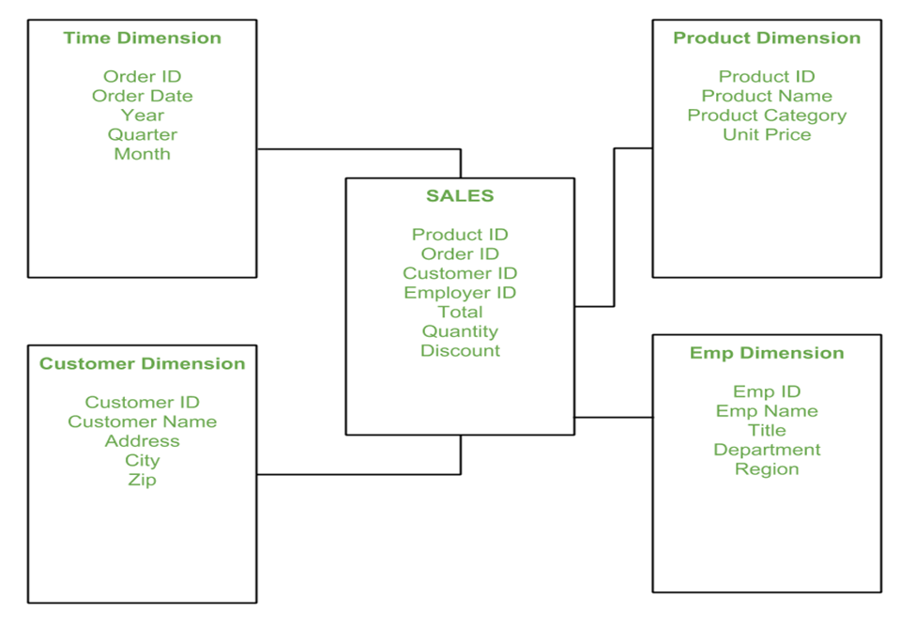
CREATE DATABASE sales;
USE sales;
CREATE TABLE time_dim (
order_id INT PRIMARY KEY,
order_date DATE,
year INT,
quarter INT,
month INT
);
CREATE TABLE product_dim (
product_id INT PRIMARY KEY,
product_name VARCHAR(100),
product_category VARCHAR(100),
unit_price DECIMAL(10,2)
);
CREATE TABLE customer_dim (
customer_id INT PRIMARY KEY,
customer_name VARCHAR(100),
address VARCHAR(200),
city VARCHAR(100),
zip VARCHAR(20)
);
CREATE TABLE emp_dim (
emp_id INT PRIMARY KEY,
emp_name VARCHAR(100),
title VARCHAR(100),
department VARCHAR(100),
region VARCHAR(100)
);
CREATE TABLE sales (
product_id INT,
order_id INT,
customer_id INT,
emp_id INT,
total DECIMAL(10,2),
quantity INT,
discount DECIMAL(5,2),
FOREIGN KEY (product_id) REFERENCES product_dim(product_id),
FOREIGN KEY (order_id) REFERENCES time_dim(order_id),
FOREIGN KEY (customer_id) REFERENCES customer_dim(customer_id),
FOREIGN KEY (emp_id) REFERENCES emp_dim(emp_id)
);
INSERT INTO time_dim VALUES
(1, '2024-01-10', 2024, 1, 1),
(2, '2024-02-15', 2024, 1, 2);
INSERT INTO product_dim VALUES
(101, 'Laptop', 'Electronics', 50000),
(102, 'Phone', 'Electronics', 20000);
INSERT INTO customer_dim VALUES
(1, 'Alice', 'Street 1', 'Pune', '411001'),
(2, 'Bob', 'Street 2', 'Mumbai', '400001');
INSERT INTO emp_dim VALUES
(1, 'John', 'Manager', 'Sales', 'West'),
(2, 'Sara', 'Executive', 'Sales', 'North');
INSERT INTO sales VALUES
(101, 1, 1, 1, 50000, 1, 0),
(102, 2, 2, 2, 40000, 2, 5);
SELECT
c.customer_name,
p.product_name,
SUM(s.total) AS total_sales,
SUM(s.quantity) AS total_quantity
FROM sales s
JOIN customer_dim c ON s.customer_id = c.customer_id
JOIN product_dim p ON s.product_id = p.product_id
GROUP BY c.customer_name, p.product_name;
